6A^{th} Grade: Unit 11, Lesson 2

- The number line below represents the difference of $\frac{7}{8}$ and $-\frac{3}{8}$. What is the value of the distance A, in fraction form?
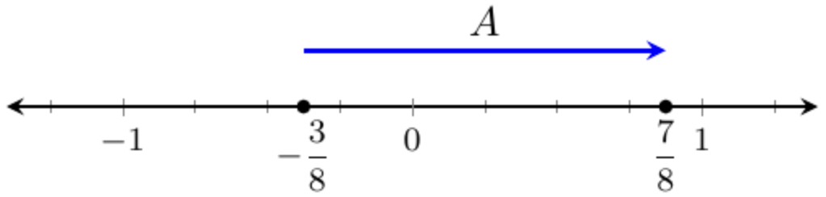

$\frac{10}{8}$ or $\frac{5}{4}$

- How can you represent the difference between 2.5 and -3.5 on a number line?

An arrow going right from -3.5 to 2.5 across the number line.

- What is the value of this expression?
$$\frac{2}{3}-\frac{1}{5}$$

$$\frac{7}{15}$$

